MINUTES TO BOARD MEETINGS

Date and Time: 20 January 2026, 10a.m

Place: Lot J1, Que Vo Industrial Zone,
(Expended Area), Que Vo District, Phuong Liew Ward,
Bac Ninh Province, Vietnam
Attendee: Roh Chung Hyun (General Director for Group)
Choi Byoung Youn (Deputy General Director)
Lim Jae Hong (Production Planning Director)
Lee Chong Jae (R&D Director)
Koh Jin Suk (QC Director)

AGENDA:

1. TECHNICAL ASSSESSMENT ON SLOW MOVING ITEMS

NOTED that Mr. Lim Jae Hong (Production Planning Director) and Ms. Ta Khanh Chi (Senior Manager – Finance) has reported on a list of slow-moving items as of 31 December 2025 totalling to VND24,874,200,354 which require technical assessment by Production Team, R&D Team and QC Team on the condition of the inventory.
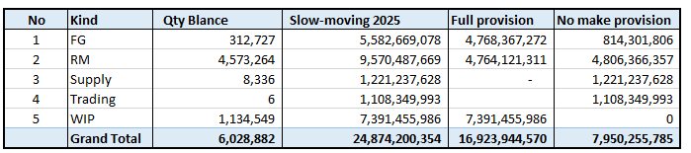

MINUTES OF MEETING

1. CONCLUSION OF TECHNICAL ASSESSMENT FOR SLOW MOVING ITEMS

RESOLVED THAT the team is hereby agreed to categorized the slow moving in the following category:

- No provision to be made for inventories totalling to VND7,950,255,785

Item listed in Appendix A are relating to be used during mass production. R&D Director has examined and advised that these items conditions are New and there is no expiry date .R&D Director has also commented that is. Production Director has confirmed the above statement by R&D Director and further add on that no provision to be made if there is still ongoing project with customer.
Regarding raw materials Production Director confirmed that he and his team has examined and verified the condition of these inventories are New and in good condition. No provision for these inventories were suggested as the inventories have no expiry date and it is commonly used in the factory. However, for packaging materials, due to change of suppliers, the person in-charge has wrongly created duplicate code for same inventory, and caused these stock were omitted for usage. The Production Director has committed that these inventories will be prioritized in consumed during the next mass production.
Supplies are still usable; the technical department will review and improve their use to utilize the remaining tools instead of purchasing new ones.

For finished and semi-finished products, the sales department will review and obtain purchase orders from customers. In cases where they cannot be sold, they will be inspected for recycling; in the worst-case scenario, they will be discarded.

- Reverse Items made provision last year VND 4,004,815,828
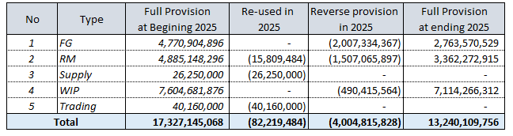

For some items, provisions were set aside last year. However, after reviewing the current situation, the Production Director found that some can still be reused.

Raw materials will be prioritized in consumed in Q1 and Q2 of 2026, and any unusable items will be considered for disposal.
Finished products will be prioritized for contacting customers to obtain purchase orders (POs). In cases where a PO is not obtained, recycling or disposal will be considered.

RESOLVED that final Board Meeting will be held on 14th January 2026, 10am to finalized the above matters.

There being no other matters, the Meeting terminated with the above.

CONFIRMED BY:

_________________________ _________________________
ROH CHUNG HYUN LEE CHONG JAE
General Director R&D Director

_________________________ _________________________
LIM JAE HONG KOH JIN SUK
Production Director Quality Control Director

